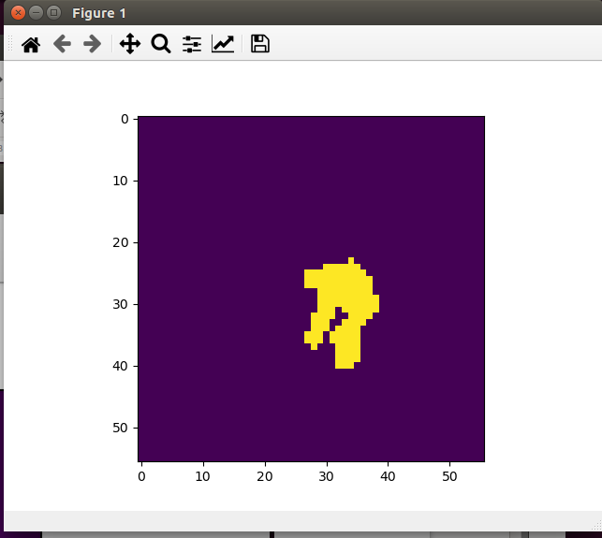

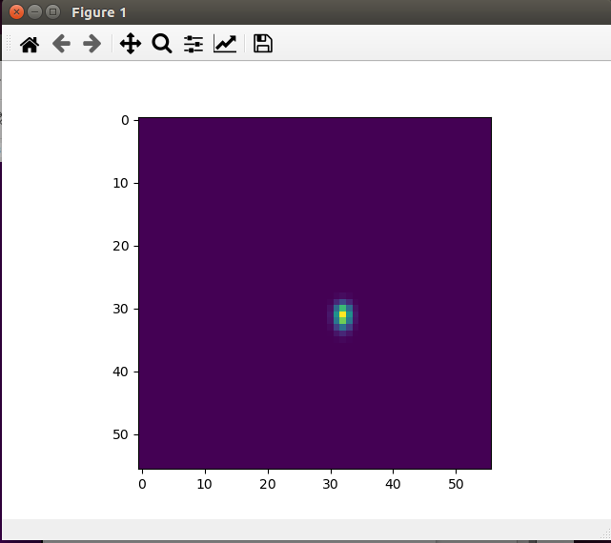

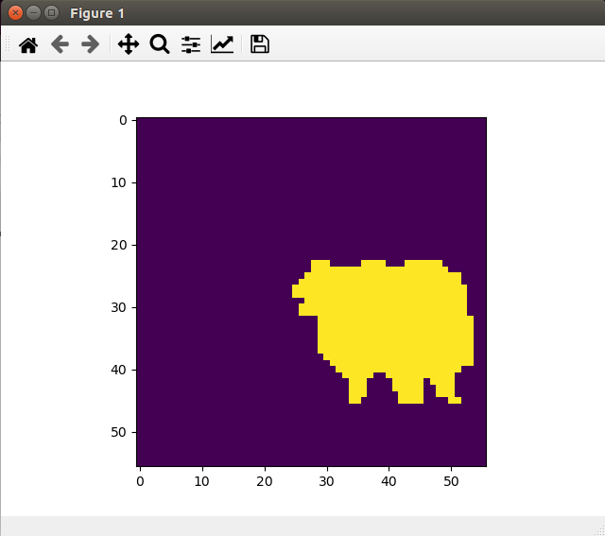

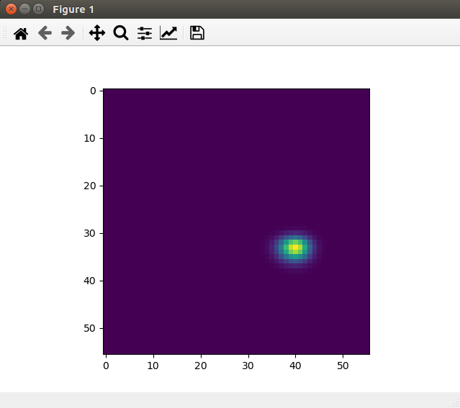

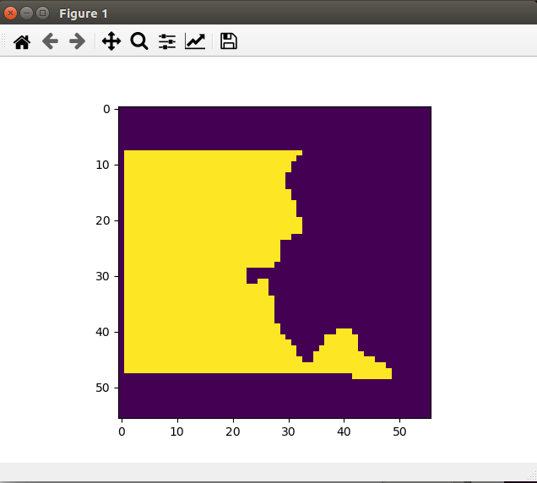

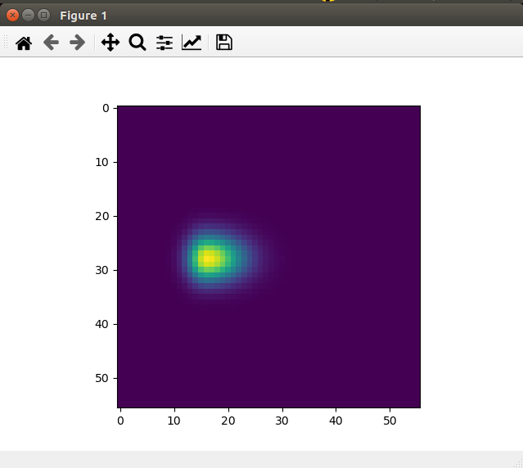

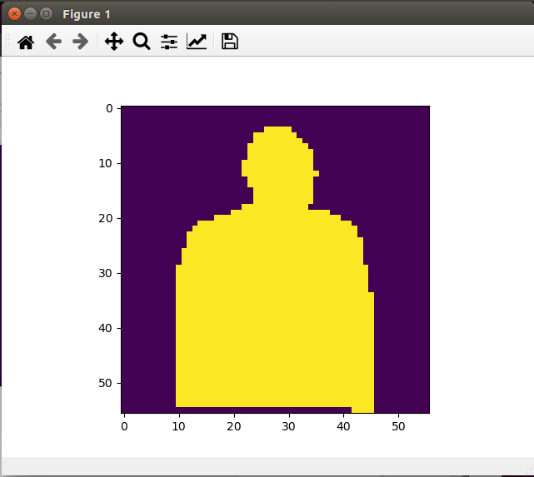

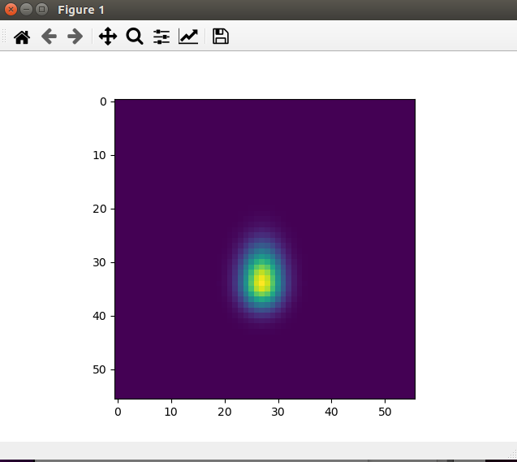

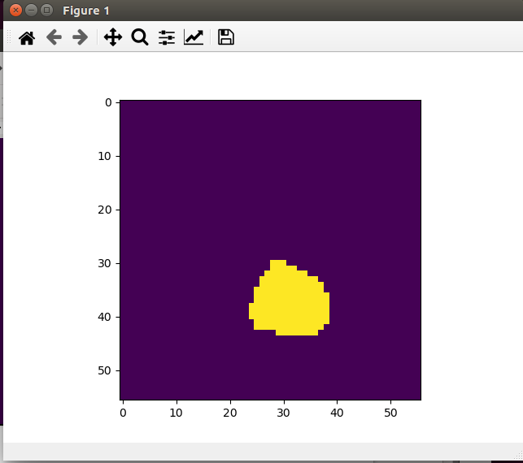

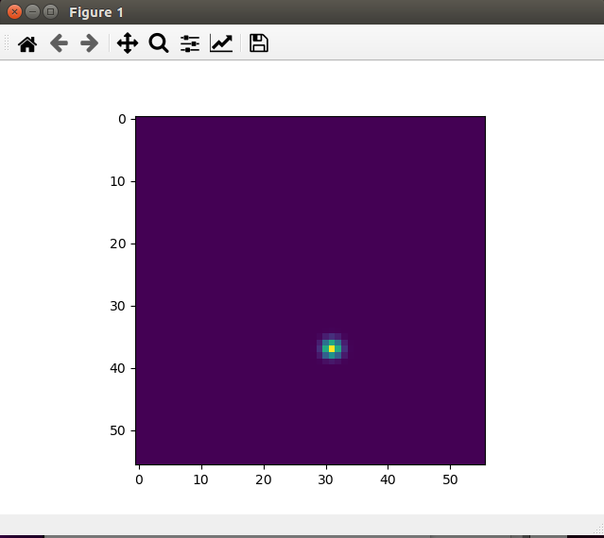

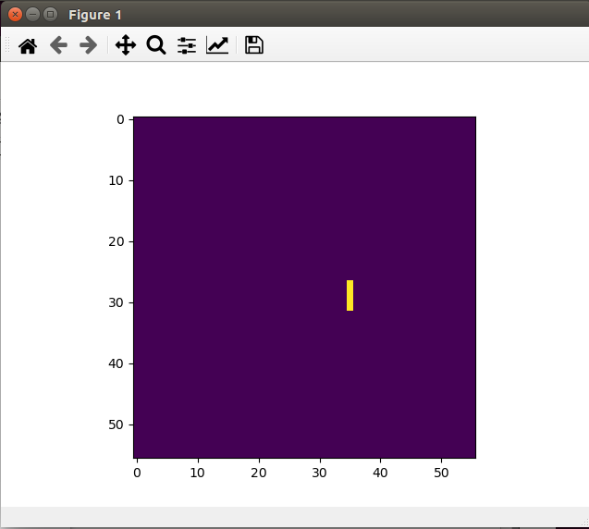

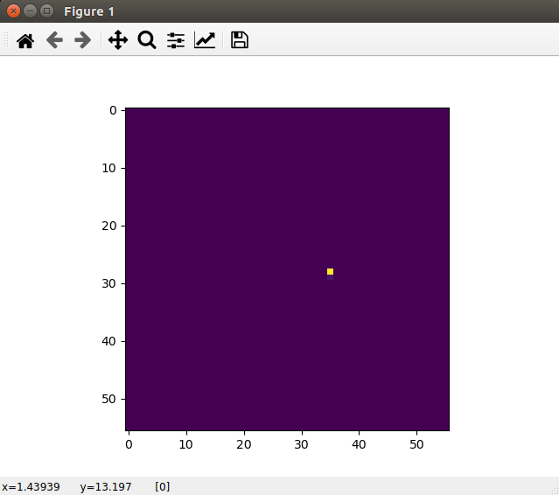

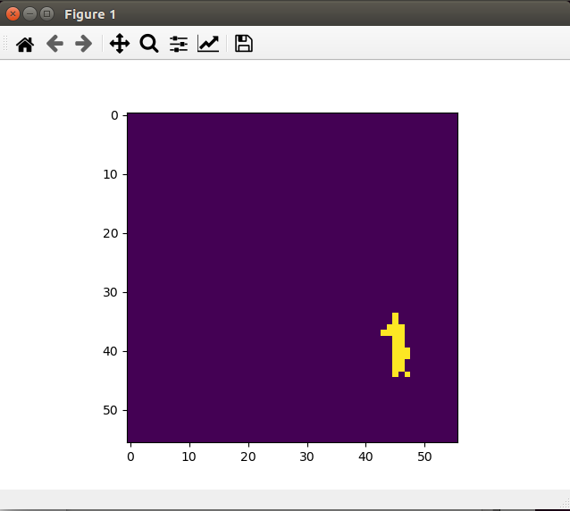

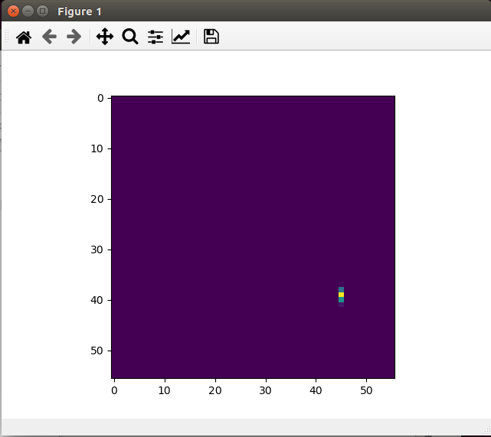

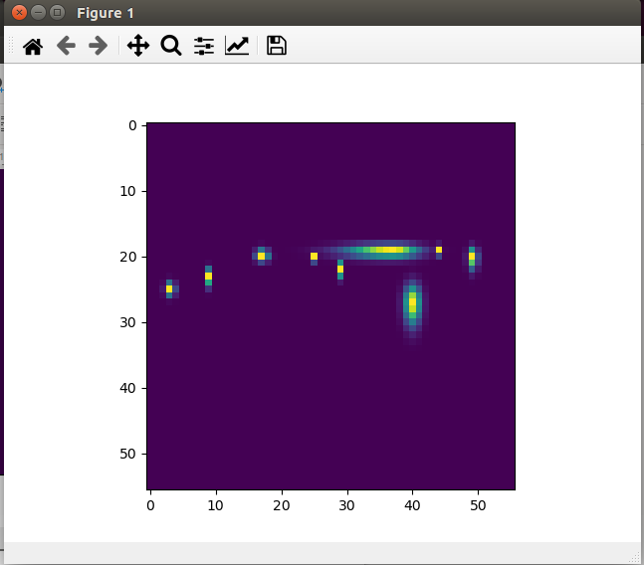

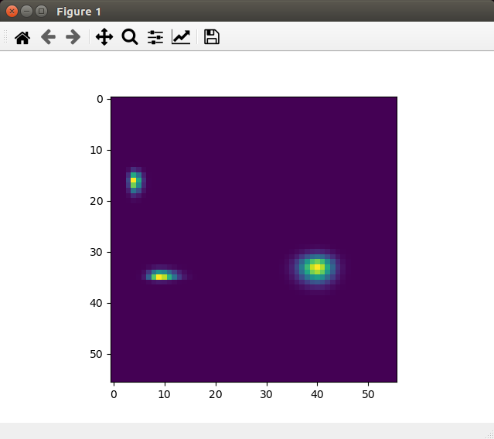

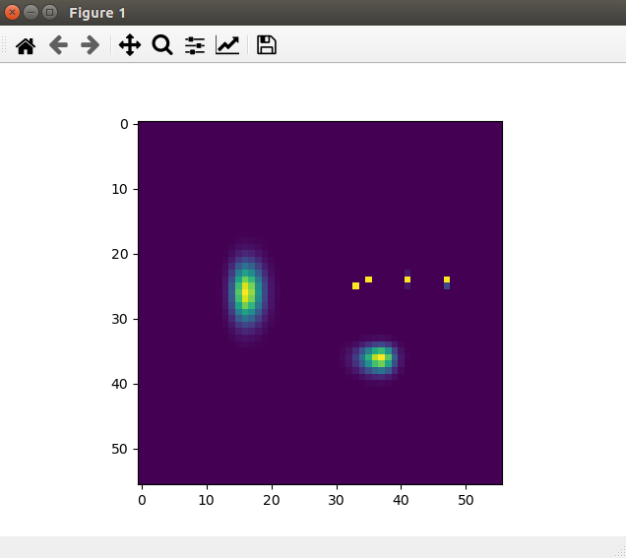
2020-01-31 20:49:32.702436: I tensorflow/stream_executor/platform/default/dso_loader.cc:44] Successfully opened dynamic library libcudart.so.10.0
2020-01-31 20:49:32.702447: I tensorflow/stream_executor/platform/default/dso_loader.cc:44] Successfully opened dynamic library libcublas.so.10.0
2020-01-31 20:49:32.702457: I tensorflow/stream_executor/platform/default/dso_loader.cc:44] Successfully opened dynamic library libcufft.so.10.0
2020-01-31 20:49:32.702468: I tensorflow/stream_executor/platform/default/dso_loader.cc:44] Successfully opened dynamic library libcurand.so.10.0
2020-01-31 20:49:32.702477: I tensorflow/stream_executor/platform/default/dso_loader.cc:44] Successfully opened dynamic library libcusolver.so.10.0
2020-01-31 20:49:32.702486: I tensorflow/stream_executor/platform/default/dso_loader.cc:44] Successfully opened dynamic library libcusparse.so.10.0
2020-01-31 20:49:32.702496: I tensorflow/stream_executor/platform/default/dso_loader.cc:44] Successfully opened dynamic library libcudnn.so.7
2020-01-31 20:49:32.702526: I tensorflow/stream_executor/cuda/cuda_gpu_executor.cc:1006] successful NUMA node read from SysFS had negative value (-1), but there must be at least one NUMA node, so returning NUMA node zero
2020-01-31 20:49:32.702868: I tensorflow/stream_executor/cuda/cuda_gpu_executor.cc:1006] successful NUMA node read from SysFS had negative value (-1), but there must be at least one NUMA node, so returning NUMA node zero
2020-01-31 20:49:32.703206: I tensorflow/core/common_runtime/gpu/gpu_device.cc:1746] Adding visible gpu devices: 0
2020-01-31 20:49:32.703226: I tensorflow/stream_executor/platform/default/dso_loader.cc:44] Successfully opened dynamic library libcudart.so.10.0
2020-01-31 20:49:32.774177: I tensorflow/core/common_runtime/gpu/gpu_device.cc:1159] Device interconnect StreamExecutor with strength 1 edge matrix:
2020-01-31 20:49:32.774194: I tensorflow/core/common_runtime/gpu/gpu_device.cc:1165] 0
2020-01-31 20:49:32.774198: I tensorflow/core/common_runtime/gpu/gpu_device.cc:1178] 0: N
2020-01-31 20:49:32.774678: I tensorflow/stream_executor/cuda/cuda_gpu_executor.cc:1006] successful NUMA node read from SysFS had negative value (-1), but there must be at least one NUMA node, so returning NUMA node zero
2020-01-31 20:49:32.778016: I tensorflow/stream_executor/cuda/cuda_gpu_executor.cc:1006] successful NUMA node read from SysFS had negative value (-1), but there must be at least one NUMA node, so returning NUMA node zero
2020-01-31 20:49:32.778358: I tensorflow/stream_executor/cuda/cuda_gpu_executor.cc:1006] successful NUMA node read from SysFS had negative value (-1), but there must be at least one NUMA node, so returning NUMA node zero
2020-01-31 20:49:32.778713: I tensorflow/core/common_runtime/gpu/gpu_device.cc:1304] Created TensorFlow device (/job:localhost/replica:0/task:0/device:GPU:0 with 10113 MB memory) -> physical GPU (device: 0, name: GeForce RTX 2080 Ti, pci bus id: 0000:01:00.0, compute capability: 7.5)
2020-01-31 20:49:32.779802: I tensorflow/compiler/xla/service/service.cc:168] XLA service 0x561c18729310 executing computations on platform CUDA. Devices:
2020-01-31 20:49:32.779812: I tensorflow/compiler/xla/service/service.cc:175] StreamExecutor device (0): GeForce RTX 2080 Ti, Compute Capability 7.5
get the head!
compute the loss!

